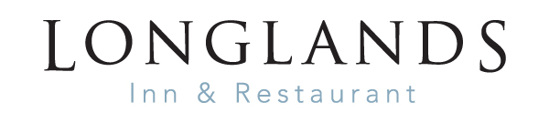
Food served Monday to Saturday 12-7pm

MAINS
Beer battered haddock, chunky chips, homemade tartare sauce
mushy peas, and curry sauce £15.00
“Fish platter” smoked salmon, salt and pepper squid, fish goujons,
prawns with Marie Rose sauce, roll mop herrings served with walnut bread £14.50
“Meat platter” Cumbrian smoked ham, Lakeland pancetta, Herdwick pastrami
chilli smoked chicken, Kendal creamy and Westmorland smoked cheddar £14.50
Chicken and leek pudding with a smoked ham, tarragon and cream sauce
tenderstem broccoli, creamy mashed potato £14.50
Panciotte with asparagus and mascarpone cheese, spring pea, truffle cream sauce £13.00

BURGERS
Longlands cheeseburger – 100% Lakeland beef served in a toasted brioche roll
caramelised onions and Mrs Kirkham’s Lancashire cheese £14.50
Plant based burger served in a toasted brioche roll, roasted red peppers
fruit chutney £14.00
All burgers served with French fries and coleslaw
PIZZAS
Cumberland sausage, blue cheese, caramelised onion £11.00 Chorizo, red onion, chilli £11.00
Meat feast £12.00
Margherita £9.00
Hot pepperoni with jalapenos £10.00
Goats cheese, caramelised onions £10.00
Cumbrian ham, with pineapple £11.0
Garlic bread £5.50
add cheese £6.50

French fries £3.50
Chunky chips £3.50

CHILDREN’S MENU
Fish and chips, garden peas £7.00
Beefburger, French fries, coleslaw £7.00
Chicken goujons, French fries, beans £7.00
Cheesy Pasta £7.00

DESSERTS
Lakeland sticky toffee pudding
Ice cream sundae
Eton mess £5.50

Choice of Ice -cream – ask for more details Per scoop £1.50
FOOD ALLERGIES AND INTOLERANCES
Some of our foods contain allergens. Please ask when ordering for more information.

