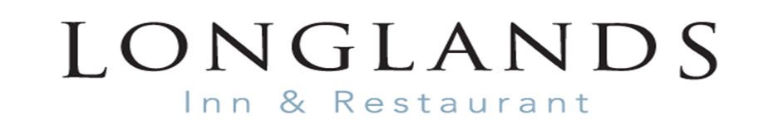
TO START
Wild garlic, cream & potato soup, goats cheese sprinkle, black onion seeds (V) (GF Alternative) £6.25
Ravioli with Formby asparagus & mascarpone, Spring peas, truffle cream, bacon crumb £8.00/£16.00 (as a main course)
Creamed garlic mushrooms, toasted sourdough, poached hen’s egg (V)(GF Alternative) £7.50
Shallow fried salt and pepper squid, stir fry vegetables, hoi sin sauce £7.50
Sharing “Meat platter” Cumbrian smoked ham, Lakeland pancetta, chicken liver pate
chilli smoked chicken, Kendal creamy and cherry smoked cheddar £16.00

MAIN COURSE
Chicken and leek pudding with a smoked ham, tarragon, and cream sauce
tenderstem broccoli, creamy mashed potato £14.50
Chargrilled leg of Cumbrian fell bred Spring lamb steak, marinated with mint and orange, Bury black pudding, sautéed potatoes, tender stem broccoli, red wine jus £21.00
Pan fried hake, mustard & tarragon sauce, crushed Jersey royal potatoes, asparagus & pea £17.00
10oz Chargrilled pork porterhouse, orange glaze, creamed mashed potato, Spring vegetables, crispy sage, red wine jus (GF) £18.00
Longlands cheeseburger, 100% Cumbrian beef served in a toasted brioche roll,
caramelised onions and Mrs Kirkham’s Lancashire cheese, chunky chips and coleslaw £14.50
Beer battered haddock, chunky chips, homemade tartare sauce, mushy peas & curry sauce £15.00
Spiced brown rice, garlic sweet potatoes, roasted nuts, charred aubergine & courgette,
spring onions (VG) £15.00
Plant based burger served in a toasted brioche roll, roasted red peppers
fruit chutney (V) £14.00

SIDES
Creamy mashed potato £4.00
Jersey Royal Potatoes £5.00
Spring Vegetables £5.00
Chunky Chips £4.00
French Fries £4.00
Dirty Fries £5.00
PIZZAS
Cumberland sausage, blue cheese, caramelised onion £12.50
Chorizo, hot chilli jam £12.00
Meat feast £12.00
Margherita £10.00
Hot pepperoni with jalapenos £11.00
Feta cheese, caramelised onions £11.00
Cumbrian ham, with pineapple £12.00
Garlic bread £6.50
add cheese £7.00

DESSERT
Sticky toffee pudding, butterscotch sauce, Walling’s vanilla ice cream £6.50
Chocolate torte, sponge-based crumble, mixed fruit compote (VG) £6.50
Strawberry brulee, shortbread biscuit £6.50
Chocolate and forest fruit sundae, Walling’s ice cream, fresh Lancashire strawberries, whipped cream £6.50
Appleby creamery cheese board, Flakebridge, cherry smoked cheddar, Kendal creamy, apricot and prune chutney, crackers and walnut bread (GF) £9.50

