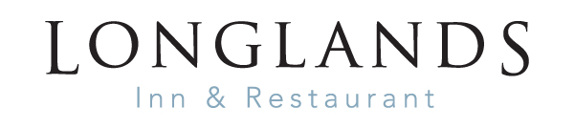
LUNCH MENU
STARTERS
Freshly baked bread, olives, houmous £6.50
Homemade cauliflower soup, bacon crumb, saffron and truffle oil,
toasted sourdough, salted butter (V)(GF) £7.00
Hot smoked salmon, poached duck egg, chive, mustard, hollandaise, watercress salad £9.50
Waldorf salad, fresh apple, celery, grapes, walnuts, blue cheese (VE) £8.00/14.50

SHARING PLATTER
Eden Valley smoked ham, Cumbrian air dried leg of lamb, Lakeland pancetta,
Lancashire smoked chicken, Mrs Kirkham’s Lancashire cheese, olives, crusty bread (GF) £19.00
MAINS
Steak Frites, peppercorn sauce, cherry vine tomatoes, French fries and salad (GF) £22.00
Beer battered haddock, hand cut chips, mushy peas, tartare sauce £16.00
Whitby Scampi, French fries, salad £15.00
Chargrilled chicken breast ciabatta, wasabi mayonnaise, French fries £11.00
Cheese, potato and onion pie, new potatoes, market vegetables (V) £15.00
Pumpkin and wild mushroom risotto, roasted carrot and pumpkin puree, toasted seeds
spiced honey (VE)(GF) £15.00

DESSERTS
Fruits of the forest cheesecake, raspberry sorbet £7.50
Cherry chocolate bread and butter pudding, vanilla crème anglaise £7.50
Baileys crème brulee, hazelnut and white chocolate shortbread (GF) £7.50
Sticky toffee pudding, vanilla ice cream £7.50
County trio cheese board, Flakebridge Eden smokie, Mrs Kirkham’s Lancashire
Garstang blue, apple, date and damson chutney, celery, apple, grapes (GF) £10.50
GF – can be made gluten free/VE – vegan alternative available Please turn over for allergen information
FOOD ALLERGIES AND INTOLERANCES
Some of our foods contain allergens. Please speak to a member of staff for more information.

Allergens | Starters |  |  |  |  | Mains |  |  |  |  |  |  | Desserts
 | Soup | Bread & Olives | Hot Smoked Salmon | Waldorf Salad | Sharing Platter | Steak Frites | Cheese & Onion Pie | Haddock | Scampi | Chicken Ciabatta | Pumpkin Risotto |  | FOTF Cheesecake | B&B Pudding | Brulee | Sticky Toffee Pudding | Cheese Board
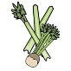Celery | √ |  |  | √
Cereals containing gluten** |  | √ |  | √ | √ |  | √ | √ | √ | √ |  |  | √ | √ | v | √ | √
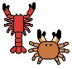
Crustations
Eggs |  |  | √ |  |  |  |  |  |  |  |  |  |  | √ |  | √
Fish |  |  | √ |  |  |  |  | √ | √ | √
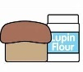
Lupin
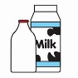  Milk | √ |  | √ |  |  | √ | √ |  |  |  | √ |  | √ | √ | √ | √ | √
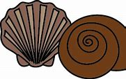
Molluscs
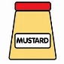  Mustard |  |  |  | √ | √ | √ | √
Nuts* |  |  |  | √ |  |  |  |  |  |  | √ |  |  |  |  |  | √
Peanuts
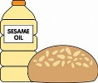  Sesame Seeds |  | √ |  | √
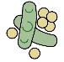
Soya
Sulphur Dioxide |  |  |  |  | √ |  |  |  |  |  | √

