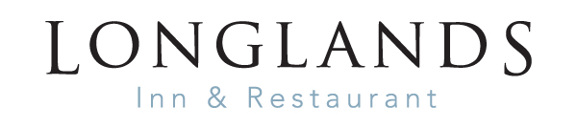

Served 1st -24th December
STARTERS
Freshly baked bread, olives, houmous £6.50
Homemade parsnip, apple caramel and ginger soup
toasted sourdough, salted butter (V)(GF) £7.00
Hot smoked salmon, poached duck egg, chive, mustard, hollandaise, watercress salad £9.50
Chicken liver pate, blackberry gel, pickled red cabbage, toasted maple walnut bread £8.50
Butternut squash and wild mushroom risotto, roasted carrot and butternut squash puree
toasted seeds, spiced honey (VE) £7.50/£15.00
TO SHARE
Baked camembert studded with garlic and rosemary, warm cranberry sauce
maple and walnut bread £14.00

MAINS
Trio of sausages, pork and marmalade, pork and leek, Cumberland
Champ mashed potatoes, red onion jus £14.50
Turkey ballontine, roast potatoes, sausage and chestnut stuffing, orange star anise
roasted root vegetables, red wine turkey jus £16.00
Cumbrian fell bred ribeye steak, peppercorn sauce, cherry vine tomatoes
triple cooked chips, salad (GF) £30.00
Braised short rib of beef bourguignon, creamy mashed potatoes £18.50
Vanilla glazed pan seared salmon, chive creamy mashed potatoes
creamy smoked mussel sauce, samphire (GF) £19.50
Beer battered haddock, hand cut chips, mushy peas, tartare sauce £16.00
Whitby Scampi, French fries, salad £15.50
Red wine, goat’s cheese, caramelised red onion, apricot and chestnut tarte tartin
salt and pepper crispy kale (V) £14.50

DESSERTS
Fruits of the forest cheesecake, raspberry sorbet £7.50
Christmas pudding, brandy and vanilla sauce, Christmas pudding ice cream £7.50
Baileys crème brulee, hazelnut and white chocolate shortbread (GF) £7.50
Sticky toffee pudding, vanilla ice cream £7.50
County trio cheese board, Flakebridge Eden smokie, Mrs Kirkham’s Lancashire
Garstang blue, apple, date and damson
chutney, celery, apple, grapes (GF) £10.50
GF – can be made gluten free/VE – vegan alternative available Please turn over for allergen information.
FOOD ALLERGIES AND INTOLERANCES
Some of our foods contain allergens. Please speak to a member of staff for more information.

Allergens | Starters |  |  |  |  | Mains |  |  |  |  |  |  |  |  | Desserts
 | Parsnip Soup | Bread & Olives | Hot Smoked Salmon | Camembert | Chicken Liver Pate | Trio of sausages | Goats Cheese | Haddock | Scampi | Turkey | Risotto | Ribeye Steak | Salmon | Bourguignon | FOTF Cheesecake | Xmas Pudding | Brulee | Sticky Toffee Pudding | Cheese Board
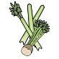Celery | √ |  |  |  |  |  |  |  |  |  |  |  |  | √ |  |  |  |  | √
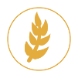  Cereals containing gluten** | √ | √ |  | √ | √ | √ | √ | √ | √ | √ |  |  |  |  | √ | √ |  | √ | √
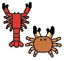
Crustations
Eggs |  |  | √ |  |  |  |  |  |  |  |  |  |  |  |  | √ |  | √
Fish |  |  | √ |  |  |  |  | √ | √ |  |  |  | √
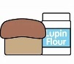  Lupin | √ | √ |  | √ | √ |  |  | √ | √
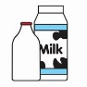  Milk | √ |  | √ | √ | √ | √ | √ |  |  |  | √ | √ | √ | √ | √ | √ | √ | √ | √
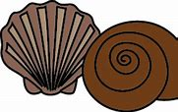  Molluscs |  |  |  |  |  |  |  |  |  |  |  |  | √
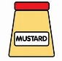  Mustard |  |  | √ | √ |  |  | √ |  | √ |  |  | √
Nuts* |  |  |  | √ | √ |  | √ |  |  |  | √ |  |  |  |  | √ |  |  | √
Peanuts
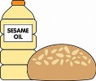  Sesame Seeds |  | √
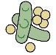
Soya
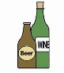  Sulphur Dioxide |  |  |  |  | √ | √ | √ |  |  | √ | √ | √ | √ | √ |  | √ | √

