
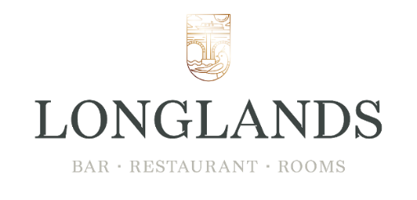
Festive Menu
Served Monday to Thursday 12.00 – 21.00, Fri & Sat 12.00-18.00
Starters
Celeriac & brown butter soup, crispy kale, saffron oil (v, vga, gfa)
Scallop gratin, rich gruyere sauce, parsley breadcrumb, bacon crumb (gfa)
Warm halloumi, orange, cranberry, roast beetroot, pine nut salad (v, vga gf)
Whipped duck & orange pate, warm duck bon bon, fig & orange chutney, warm crusty bread
Mains
Roast turkey breast, duck fat roast potatoes, pigs in blankets, roasted vegetables, sage & onion stuffing, cranberry sauce, turkey jus (gfa)
Cannon of beef, parsley mash, charred root veg, port & juniper berry jus (gf)
Salmon, cod, king prawn lobster bouillabaisse (gf)
Butternut squash, lentil, almond wellington, roasted root vegetables (vg)
Desserts
Lemon drizzle cheesecake, raspberry sorbet (v)
Christmas pudding, brandy sauce (vga)
Caramel & chocolate tart, vegan vanilla ice cream (vg, gf)
Coffee and mince pie
2 courses £28.00, 3 courses £32.00
A £10 non-refundable, non- transferable deposit is required on all bookings 10 or more
(v – vegetarian, vg – vegan, vga – vegan alternative available, gf – gluten free, gfa – gluten free alternative available)

