Pizza Menu
Our thin crust 12” pizzas are made from wheat flour and are stone baked to create a light crisp crust.

Garlic bread (v) £8.50

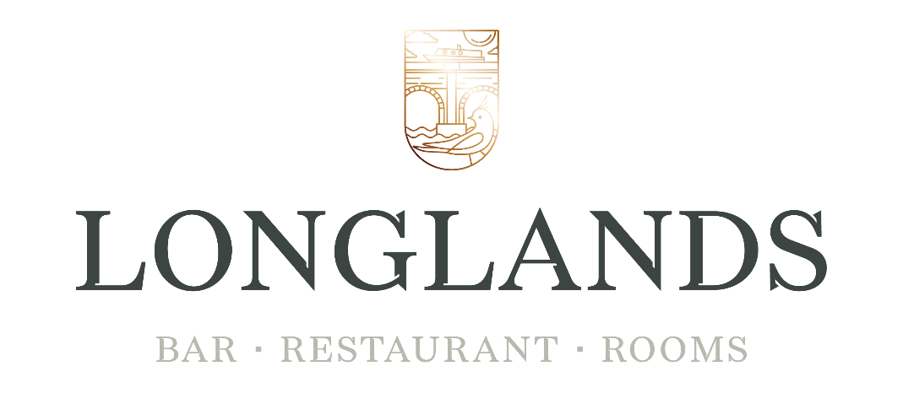
Garlic bread with cheese £11.00

Margherita £14.00
Mozzarella, tomato & oregano

Pepperoni £16.50
Mozzarella, tomato

Bbq pulled pork £16.50
Charred pineapple

Black cajun chicken £16.50
Chicken, sweetcorn, mango chutney

Mushroom (v) £16.00
Chestnut field mushrooms, paprika, truffle garlic & spinach oil

Mediterranean vegetables £16.50
Feta, balsamic glaze (v)

Ultimate meat feast £16.50
Tomato & oregano

Sides £5.75
Chips, fries, onions rings, house salad

Please be aware due to the ovens our pizzas are cooked in we cannot offer gluten free pizzas

Our pizzas can be eaten in or for take away

